ANALYSIS OF OPEN ACCESS JOURNALS IN UROLOGY: AN ANALYTICAL STUDY

Munugala Srinivasulu
Research Scholar,
Department of Library and Information Science, Sri Krishnadevaraya University, Anantapuramu-515 003, Andhra Pradesh, India
srinu.edu752@gmail.com

and

Dr. Chandran Velmurugan
Chief Librarian, Meenakshi Medical College Hospital and Research Institute,
Kanchipuram-631 552, Tamilnadu, India
Email: murugan73@gmail.com
http://orcid.org/0000-0002-6628-7644

ABSTRACT

An open access scientific journal is a peer-reviewed publication that is available for free online, allowing users to search, read, copy, share the link, download, and print full-text research papers. Urology is a medical practice that focuses on urinary tract problems in both men and women. An urologist is a physician who specializes in the urinary system. Back in the day, doctors would examine a patient's urine for evidence of their illness. Urology, often known as genito-urinary surgery, is a surgical and medical specialty that focuses on the male and female urinary tract organs. This paper has analyzed the urology open access journals which are available in DOAJ (Directory of Open Access Journals). The results reveal that DOAJ indexes 12 open access journals published by Elsevier and followed by 8 journals are published by Wolters Kluwer Medknow. The other publishers such as Hindawi Limited 5 journals, Karger Publishers 4 journals. It is found that there are 37 blind peer review journals followed by 32 double blind peer review journals and 11 peer-reviews journals respectively indexed in DOAJ database. It is discovered in the study that maximum journals (74) in Urology are without DOAJ seal and only 8 journals have got the desired DOAJ seal, which represents as a symbol of certification and high publishing standards.

Keywords: Bibliometrics, Scientometrics, DOAJ, OA, Urology, Open access journals, Urologic
Symptoms, genito-urinary surgery, Library Science.

INTRODUCTION

Directory of Open Access Journals in short “DOAJ” was launched in 2003 at Lund University, Sweden with 300 open access journals. Today, this independent index contains almost 17 664 peer-reviewed open access journals with 7, 474, 264 articles with 80 languages under 130 countries as on 24th May 2022. Out of 17664 journals, 12, 281 journals publish articles without article processing charges. This open access journals covers all areas of science, technology, medicine, social sciences, arts and humanities. Open access journals from all countries and in all languages are accepted for indexing. DOAJ is financially supported by many libraries, publishers and other concurring organizations. DOAJ is acting as a co-author to the Principles of Transparency and Best Practice in Scholarly Publishing (https://doaj.org/).

Bibliometrics is one the methods of quantitative analysis which is used to identify the research growth of publications of individuals, particular department or two or more department publications, organizations, research institutions, management organizations etc. Bibliometric techniques are being used in every discipline to evaluate current trends in research growth and development, to examine the research productivity of authors and organizations and even the inter-discipline relationships. Bibliometric study is carried out on account of some characteristics to estimate research literature. The major parameters which are used for bibliometric research such as record or publication counts, productive citation record, institution counts, co-citation analysis, co-word analysis, authorship pattern, research area, funding agencies, collaborative research etc. The present study tried to focus on through bibliometric study of open access urology journals which are indexed in DOAJ database bibliometric study of all journals in the field of mathematics indexed in DOAJ database.

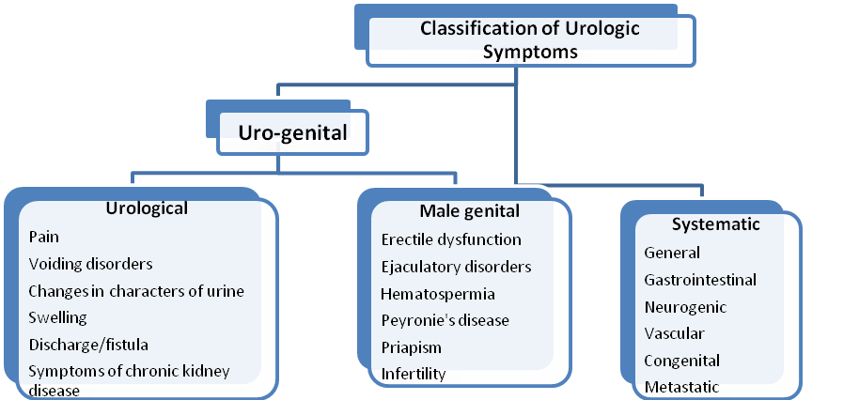

Figure 1: Classification of Urologic Symptoms

Urology is a specialty of medicine that focuses on diseases of the urinary tract in both men and women. An urologist is a medical specialist who focuses on the urinary system. Doctors used to check a patient's urine for signs about their ailment back in the day. Urology is also called as genito-urinary surgery which deals with the surgical and medical diseases of the male and female urinary tract organs such as kidneys, adrenals, ureters, urinary bladder, and urethra, and the male reproductive system such as testes, epididymis, vas deferens, seminal vesicles, prostate and penis. Urology is closely related to oncology, nephrology, gynaecology, andrology, pediatric surgery, colorectal surgery, gastroenterology, and endocrinology. The above Figure 1 indicates the general classification of urologic symptoms.

UROLOGY POPULAR JOURNALS AND ORGANIZATIONS

According to Wikipedia (2022), there are a number of peer-reviewed journals and publications about urology, particularly, the most popular journals such as The Journal of Urology, European Urology, the African Journal of Urology, British Journal of Urology International, BMC Urology, Indian Journal of Urology, Nature Reviews Urology, and Urology. In addition, there are national organizations such as the American Urological Association, the American Association of Clinical Urologists, European Association of Urology, the Large Urology Group Practice Association (LUGPA), and The Society for Basic Urologic Research. Urology is also included under the auspices of the International Continence Society. Teaching organizations are the European Board of Urology, and the Vattikuti Urology Institute in Detroit, which also hosts an annual International Robotic Urology Symposium devoted to new technologies and in developing countries, the non-profit organization like the American non-profit IVUMed teaches urology (https://en.wikipedia.org/wiki/Urology)
.
PREVIOUS WORK

Jatinder Kumar (2016) analyzed the open access journals of mathematics indexed in doaj database via bibliometric analysis during 2016. He found that total of 556 journals in mathematics and the huge number of journals in mathematics was indexed under ‘science’ subject and the maximum number of journals was added during the year 2013, and also noted that India was the leading contributor for mathematical journals. Mondal (2016) conducted on Open access journals in SAARC countries and the survey found among the 765 open access journals, India produced vast number of (77.12%) Open access journals. It also noticed that out of 765 SAARC journals, greater part of 33.59% of the journals from commercial domain (.com) and 30.19% of the journals from institutional domain (.org). Maity and Teli (2015) carried out a study to examine the huge productivity in Library and Information Science and Communication Technology, followed by Library and society, Library association and then by Management and the least productivity were Altmetric, Webometric, Public library, Special Library etc.

Aswathy and Gopikuttan (2013) discovered through their study that 79 journals in general physics with 5.63% among twelve divisions. They also noted 13.07% in astronomy and 11.11% in optics and lights. Thavamani (2013) studied to identify the 151 Library and Information Science open access journals and the data collected from the DOAJ website covering the Library and Information Science journals during 2003-2013. The study identified that the massive number of 139 (92.053%) journals were not collected article processing fee and the remaining seven journals collecting fee. Lihitkar and Shalini (2013) conducted a study and found the major proportions of LIS journals were published in United States and occupied the first rank. Another study carried out by Kumar et al. (2012) and found India ranked first in journals in the Directory of Open Access Journals (DOAJ) and 11th place in the world repository during the research.

RESEARCH QUESTIONS

Data in the field of urology was collected directly from the Directory of Open Access Journals (DOAJ) website for descriptive analysis in terms of subjects and their interests, journal characteristics, types of journal licenses, publication fees, country of publication, journal organization, peer review type and publisher distribution, chronologically organized journals, and so on. This study poses and attempts to answer five basic research questions based on the research technique:

1. What are the characteristics of DOAJ's Urology publications?
2. What are the most often identified Urology subjects in DOAJ?
3. What types of journals can be found in the Urology Open Access Journals?
4. What is the most common language used in Urology open access journals?
5. Which nations contribute the most open access journals in the field of Urology?

OBJECTIVES OF THE STUDY

The primary goal of this study is to determine the number of online open access scholarly and scientific publications in urology discipline through the Directory of Open Access Journals (DOAJ) from January 2002 to May 2022, with the following secondary goals:

- To demonstrate the chronology-based distribution on Urology
- To identify the many types of Open Access Journals on Urology and their formats.
- To observe how the DOAJ seal and Article Processing Charges (APCs) in urology.
- To look at the rankings of urology journals by country.
- To determine the distribution of open access urology journals by language.
- To investigate the distribution of urology peer-reviewed journals.
- To find out the Publisher wise distribution during the research period

MATERIAL AND METHODS

In order to estimate the research output, the researchers have chosen bibliometric technique to analyze the research trends of open access journals in Urology. To execute the above objectives, the necessary data was collected through Directory of Open Access Journals database. It is found from the DOAJ database, 17 664 peer-reviewed open access journals with 7, 474, 264 articles with 80 different languages under 130 countries as on 24th May 2022. Out of 17664 journals, 82 open access urology journals are indexed in urology subject from January 2002 to May 2022 and except the years from 2006 to 2007 as the data were not available those periods. The investigation was done through various elements such as chronology wise and country and subject wise, publisher and language, journals license and format wise contribution etc.

SCOPE AND LIMITATIONS

This research is confined to Open Access scholarly and scientific journals in Urology discipline with only 82 electronic journals which are available in the Directory of Open Access Journals (DOAJ) database till the date 24th May 2022. The other research areas or subjects or online and open access journals are not included.

ANALYSIS AND RESULTS

To assess the contribution of open access journals in Urology which are appeared in DOAJ, it discussed different parameters such as year and country wise distribution, subject coverage, publisher and language wise contribution, journals license, format wise contribution etc. The analysis was done based on the retrieved data, and results and findings and discussions have been demonstrated below.

Distribution by Year

Table 1 Figure 1 display that the contribution of free open access journals in the field of Urology Science from the Directory of Open Access Journals database during the period between January 2002 and May 2022. The results reveal that out of 82 urology journals, the maximum number of 12 (14.62%) journals were added in 2018 and followed by 10 journals were added during the year 2016 with a percentage of 12.19%. surprisingly, there is a steep downfall in the yearly addition of urology journals after 2018. It is also identified that there is no journals were added in the year 2006 and 2007 respectively. The growth rate of adding journals in this filed gradually decreased after the year 2018 as per the data.

Table 1: Distribution by Year
S. No | Year | Frequency | Frequency Cum. | Percentage | Percentage cum
1 | 2022 | 1 | - | 1.22 | -
2 | 2021 | 8 | 9 | 9.77 | 10.99
3 | 2020 | 8 | 17 | 9.77 | 20.76
4 | 2019 | 7 | 24 | 8.53 | 29.29
5 | 2018 | 12 | 36 | 14.62 | 43.91
6 | 2017 | 7 | 43 | 8.53 | 52.44
7 | 2016 | 10 | 53 | 12.19 | 64.63
8 | 2015 | 7 | 60 | 8.53 | 73.16
9 | 2014 | 3 | 63 | 3.66 | 76.82
10 | 2013 | 2 | 65 | 2.44 | 79.26
11 | 2012 | 2 | 67 | 2.44 | 81.70
12 | 2011 | 3 | 70 | 3.66 | 85.36
13 | 2010 | 3 | 73 | 3.66 | 89.02
14 | 2009 | 3 | 76 | 3.66 | 92.68
15 | 2008 | 2 | 78 | 2.44 | 95.12
16 | 2005 | 1 | 79 | 1.22 | 96.34
17 | 2004 | 1 | 80 | 1.22 | 97.56
18 | 2003 | 1 | 81 | 1.22 | 98.78
19 | 2002 | 1 | 82 | 1.22 | 100
Total |  | 82 |  | 100

Figure 1: Distribution by Year
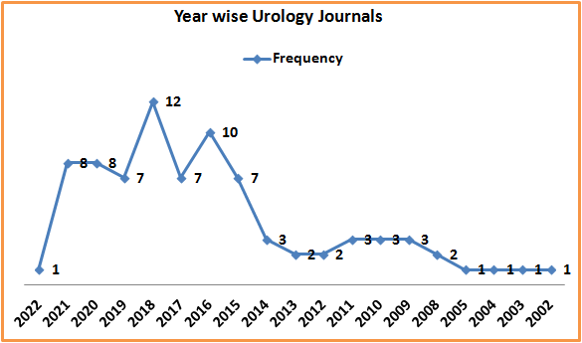

Distribution by APCs

Table 2 enumerates the processing fee such as Article Processing Charges (APCs), submission charges, page charges, colour charges etc is required to complete the publication process. In which out of 82 open access journals, the maximum number of 42 (51.22%) journals are not charging processing fee for publication whereas the remaining 40 (48.78%) urology journals collecting article processing charges (APCs) during the research period.

Table 2: Distribution by APCs
S. No | Article processing charges | Frequency | Total
1 | Yes | 40 | 48.78
2 | No | 42 | 51.22
Total |  | 82 | 100

Distribution by DOAJ Seal

Researcher has tried to explore the contribution of DOAJ seal and Article Processing Charges (APCs) of open access scholarly journals in Urology during the study period. It is inferred from the below table 3 that out of 82 DOAJ open access journals, the majority 74 journals do not have the DOAJ seal and only 8 journals have the DOAJ seal during the study period.

Table 3: Distribution by DOAJ Seal
S. No | DOAJ Seal | Frequency | Total
1 | Yes | 8 | 9.76
2 | No | 74 | 90.24
Total |  | 82 | 100
Distribution by Journal License

By and large, the journals are permitted to reuse the content in line with a Creative Commons license or other type of license with some protocol. Journals have the a range of licenses such as CC By, CC By-NC, CC By-NC-ND, CC By-NC-SA, CC By-ND and CC By-SA and others (https://doaj.org/application/new). According to table 4, the majority of 52 (63.42%) journals in urology having CC BY license and followed by 15 (18.29%) journals comes under CC By-NC-ND and only 3 (3.66%) journals having CC BY-NC-SA license.

Table 4: Distribution by Journal license
S. No | Journal license | Frequency | Total
1 | CC BY | 52 | 63.42
2 | CC BY-NC-ND | 15 | 18.29
3 | CC BY-NC | 12 | 14.63
4 | CC BY-NC-SA | 3 | 3.66
 |  | 82 | 100

Distribution by Publishers

Top ten Publishers have been taken for account in urology open access journals and found the majority of 12 journals are being published by Elsevier, and followed by 8 journals are published by Wolters Kluwer Medknow. The other publishers such as Hindawi Limited 5 journals, Karger Publishers 4 journals and SAGE Publishing, Dove Medical Press, and BioMed Central publishers each 3 journals respectively. The publishers like Galenos Yayinevi, European Medical Journal, Codon Publications publish each 2 journals respectively. It is observed that some other publishers have also good quality numbers of journals are being indexed in DOAJ. Based on the results, it is very clear from the below table that Elsevier is the well known and the biggest publisher and supporter of Open Access scholarly research out on Urology contents.

Table 5: Distribution by Publishers
S. No | Publisher | No of journals
1 | Elsevier | 12
2 | Wolters Kluwer Medknow | 8
3 | Hindawi Limited | 5
4 | Karger Publishers | 4
5 | SAGE Publishing | 3
6 | Dove Medical Press | 3
7 | BioMed Central | 3
8 | Galenos Yayinevi | 2
9 | European Medical Journal | 2
10 | Codon Publications | 2

Languages wise distribution

It is found that Urology electronic open access journals published through seven languages such as English, Spanish, Turkish, Ukrainian, Russian, Portuguese, and Italian. Table 6 and Figure 2 depicts that the vast number of 72 (87.80%) urology journals published their research articles in English as expected. Four journals publish their papers in Spanish language and two journals are publishing in Turkish language and one journal is publishing in four languages such as Ukrainian, Russian, Portuguese, and Italian in each.

Table 6: Languages wise distribution
S. No | Languages | No of Journals | Percentage
1 | English | 72 | 87.80
2 | Spanish | 4 | 4.88
3 | Turkish | 2 | 2.44
4 | Ukrainian | 1 | 1.22
5 | Russian | 1 | 1.22
6 | Portuguese | 1 | 1.22
7 | Italian | 1 | 1.22
Total |  | 82 | 100

Figure 2: Languages wise distribution
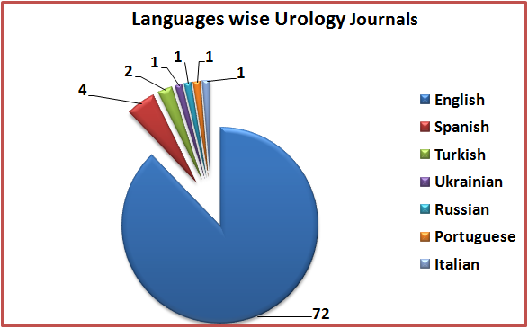

Analysis of Publication Countries

It is inferred from the Table 7 and shows the top ten countries with greatest number of journals in Urology. It found that the United Kingdom is leading contributor with 19 journals in Urology indexed in DOAJ database, and followed by United States has occupied the 2nd rank with 10 journals and India has got ranked third place with 8 journals. Turkey and Spain have got least rank with 3 journals respectively. It is noticed that some other countries have also share their contributions in this field. The result reveals from this table is pretty interesting, as maximum contributions in the field of Urology originate from Europeans countries.
Table 7: Distribution by Country (Top 10)
S. No | Country of publisher | No of Journals
1 | United Kingdom | 19
2 | India | 8
3 | Russian Federation | 5
4 | Korea, Republic of | 4
5 | United States | 10
6 | Switzerland | 4
7 | Turkey | 3
8 | Spain | 3
9 | Netherlands | 4
10 | Iran, Islamic Republic of | 5

Distribution by Peer-Review

Academic research output have been reviewed under different parameters such as Blind peer review, Double blind peer review, Peer review and Open peer review and other types. Table 8 and Figure 3 illustrate in Urology open access journals and review pattern during the research, the massive amount of 45.12% of journals comes under Blind peer review and followed by 39.02% of the journals were under Double blind peer review and only two journals with 2.44% comes under open peer review.

Table 8: Distribution by Peer-Review
S. No | Peer review | Frequency | Total
1 | Blind peer review | 37 | 45.12
2 | Double blind peer review | 32 | 39.02
3 | Peer review | 11 | 13.41
4 | Open peer review | 2 | 2.44
Total |  | 82 | 100

Figure 3: Distribution by Peer-Review
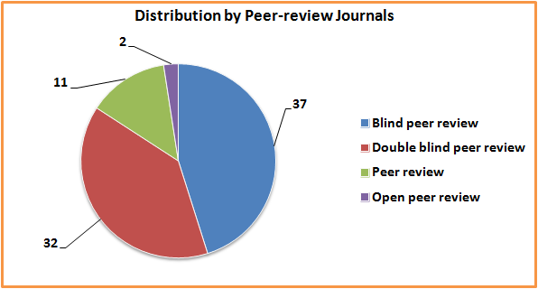

Research Areas

Table 9 Figure 4 displays that research area wise distribution of journals in the field of urology. Out of 10 research domain, the major proportion of 31 (37.8%) journals covers only urology nephrology field. The productive urology journals cover pediatrics with 19.51% and followed by 12 (14.63%) journals occupy surgery field and only 1.22% of the journals cover Public Environmental Occupational Health and Reproductive Biology each.

Table 9: Research Area wise distribution
Research Areas | No of Journals | Percentage
Urology Nephrology | 31 | 37.80
Pediatrics | 16 | 19.51
Surgery | 12 | 14.63
General Internal Medicine | 7 | 8.54
Oncology | 5 | 6.10
Pharmacology Pharmacy | 4 | 4.88
Obstetrics Gynecology | 3 | 3.66
Immunology | 2 | 2.44
Public Environmental Occupational Health | 1 | 1.22
Reproductive Biology | 1 | 1.22
Total | 82 | 100

Figure 4: Research Area wise distribution
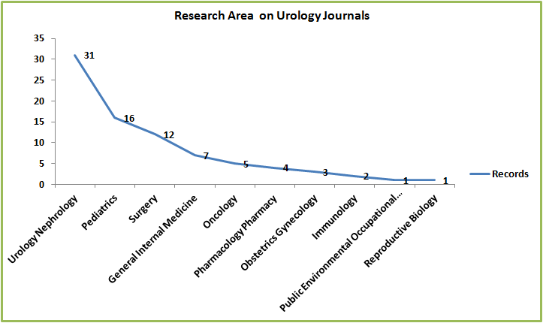

MAJOR FINDINGS

The present study has made an investigation to carry out a bibliometric analysis of Urology open access journals which are indexing in DOAJ database. The following results are reported after the data analysis.

- It is reported that since 2002, the maximum numbers of journals in Urology (12) were added in the year 2018. But, at present, there are 82 journals in Urology indexed in DOAJ database.

- It is found that DOAJ indexes 12 open access journals published by Elsevier and followed by 8 journals are published by Wolters Kluwer Medknow. The other publishers such as Hindawi Limited 5 journals, Karger Publishers 4 journals.

- It is found that there are 37 blind peer review journals followed by 32 double blind peer review journals and 11 peer-reviews journals respectively indexed in DOAJ database.

- It is discovered in the study that maximum journals (74) in Urology are without DOAJ seal and only 8 journals have got the desired DOAJ seal, which represents as a symbol of certification and high publishing standards.

- Another remarkable finding of the study is that maximum open access journals originate from developing countries and it is found that in case of Urology, 19 journals published in United Kingdom and followed by United States has occupied the 2nd rank with 10 journals and India has got ranked third place with 8 journals.

- It is observed that being universal language as English is preferred text language of maximum open access journals. The journals were written in other languages like Spanish, Russian, Turkey etc. are comparatively less in numbers.

- It is reported that the majority of 31 (37.8%) journals covers only urology nephrology field. The next productive urology journals cover pediatrics with 19.51% and followed by 12 (14.63%) journals occupy surgery field.

SUGGESTIONS

It is suggested during the analytical study that Urology websites, blog, social media like face book should provide users links for free e-journals which are available in DOAJ and they will be very useful to urology students, researcher and urologists to know about them. The Urology professionals have to create more awareness about free e-journals.

DISCUSSION AND CONCLUSION

The DOAJ is an effective database which provides access to quality controlled Open access journals and the DOAJ is a valuable and significant source of information for the present day and there is no alternative and substitute to its great quantity, efficacy, and efficiency. A huge number of research works have already done and still doing in the field of open access journals and books recently. A few numbers of studies have discussed to strengthen the present research.
Findings from the study of Sahoo, birtia and Mohanty (2017), found that there were only 13 open access journals in the discipline of library and information science which are indexing on DOAJ during 2103 whereas the number had gradually increased in 2016 as 158 OA Journals. Pujar (2014) examined on open access journals in the field of library and information science which are indexing in DOAJ. The findings of the study showed that huge number of journals produced from United States. More than 70 percent of the journals were written English language. Husain and Nazim (2013) analyzed that most of the open access journals in Media and Communication were published during late 1990s and published in 34 different countries of 6 continents. Brazil had got placed the first rank, and followed by USA, Spain, Australia and Canada. It is also found that huge number of the public funding research institutions in India had started providing free access to their journals. Findings of the study by Kumar et al (2012) India produced more number of (4.11%) open access journals in DOAJ and had ranked first in the field of agriculture and food sciences. It found from the study that Indian researchers and eminent scholars had continuously contributed to open access literature as some of the premier institutions, particularly in the field science and technology. Sivakumaren, et al., (2012) found through his study that most of the open access journals were published from USA in the area of Library & Information Science whereas only 5 open access journals were published from India. It was also noted that English was the most popular language of communication among LIS open access journals. Agashe, Lihitkar & Lihitkar (2010) examined and identified most of the (48) Business and Management e-journals were found in the DOAJ and USA had ranked first with ten online journals and followed by Brazil. English was the most universal language as written by 41 electronic journals. Lone, Rather & Shah (2008) identified India was constantly contributing in open access scholarly publications since several number of leading institutions, predominantly in the field of science and technology which are providing open access to their research publications and found that India was in the 7th place in the DOAJ and followed by Sweden and Spain have got ranked in the 10th position in Directory of Open Access Repositories in the globe. The observation and investigation of this research on urology which will definitely helpful for urologists as a guide to students, researchers, scholars about free, full-text, quality-controlled scientific and scholarly journals in Urology discipline. Moreover, the DOAJ provides most high profile and heavily used free e-resources in the entire subject. The findings of the study will help and stop subscribing in print and can save fund. The results of present study can be useful for Urology scientists studying and their research work as the free e-journals are available in accepted standards and the users are using free e-journals with full satisfaction.

FUTURE RESEARCH

The current study is mainly focused on the quantitative research in the field of urology online journals. But, in future, the research should be taken into quality control metrics in terms of impact factor of the journals and h-index of authors to encompass a better insight of the quality based journals in the discipline of urology and related area.

REFERENCE

- Aswathy, S and Gopikuttan, A. (2013). Open Access literature productivity of Physics: A DOAJ Perspective, Library Philosophy and Practice (e-journal), 971. http://digitalcommons.unl.edu/libphilprac/971

- Jatinder Kumar. (2016). Bibliometric Analysis of Open Access Journals in Mathematics Indexed in DOAJ Database. Journal of Advancements in Library Sciences, 3(2), 50-88.

- Kumar, G H. et al. (2012). India's contribution to Agriculture and Food Sciences through open access literature, DESIDOC Journal of Library and Information Technology, 32 (1), 53-58.

- Lihitkar, R & Shalini R. L. (2013). Open Access Library and Information Science Journals on DOAJ: An Analytical Study, International Journal of Advanced Library and Information Science,1(1), 33-61.

- Maity, A & Teli, S. A. (2015). Bibliometric Analysis on the Directory of Open Access Journals (DOAJ) in the Subject Domain of LIS from the year 2004-2014, International Journal of Innovative Research in Science, Engineering and Technology, 4(4), 1955-1962.

- Mondal, D. (2016). Open access journals in SAARC countries with special reference to DOAJ: A study, International Journal of Information Dissemination and Technology, 6(2), 73-76.

- Thavamani, K. (2013). Directory of Open Access Journals: A Bibliometric Study of Library and Information Science, Collaborative Librarianship, 5 (4), 245-255.

- Velmuruagn, C. (2018). Scholarly Communications of Nephrology by Indian Scientists in Science Citation Index Expanded: a Scientometric Profile, Library Philosophy and Practice, 1716, 1-13.

- Husain, S & Nazim,M. (2013). Analysis of Open Access Scholarly Journals in Media & Communication. DESIDOC Journal of Library & Information Technology, 33, (5), 405-411.

- Kumar, G.H.et al. (2012). India’s Contribution to Agriculture and Food Sciences through Open Access Literature. DESIDOC Journal of Library & Information Technology, 32, (1), 53-58.

- Lone, F.; Rafiq R. & Shah, G.J. (2008). Indian contribution to open access literature: A case study of DOAJ & Open DOAR. Chinese Lib.: An Int. Electr. J., 26, 1-10. http://www.iclcs.us/cliej/c126fayaz.htm/ (accessed on 15 September 2022).

- Sivakumaren, K.S., et al. (2012). A study on open access journals in library and information science: With reference to DOAJ. Int. J. Lib. Sci., 6(2).

- Agashe, A.T.; Lihitkar, S.R. & Lihitkar, R.S. (2010). Free online journals on business and management in directory of open access journals (DOAJ). SRELS J. Inf. Manag., 47(1), 41-58.

- Pujar, S.M. (2014). Open access journals in library and information science: a study. Annals of Library and Information Studies, 61(3), 199-202.

- Sahoo, J., Birtia, T., & Mohanty, B. (2017). Open access journals in library and information science: A study on DOAJ. International Journal of Information Dissemination & Technology, 7 (2), 116-119.

