The Editor
International Biological and Biomedical Journal Date:16-6-2023

Dear Sir/Madam
Manuscript Title: ...... Injection Depot Medroxy Progesterene Acetate (DMPA): Our experience........................................
Category: .. Original Research..................
- Running title: .... Injection DMPA : Our experience at tertiary care hospital
Authors: first name Last name
1.... ........Dr Swati Gurav.............

2........... Dr Uma Wankhede..........
Corresponding author: Dr. Swati Gurav.........,
Affiliation:.......B.J.GMC, B.J. Government Medical College, PUNE.................
Postal code: ....411001............................
Email: ........... swati.gurav2009@gmail.com............................
Tel: 8552993111/ 9765560604. ..........................................
Fax: ...........................................
I would like to submit the above manuscript in The International Biological and Biomedical Journal. I confirm that the final manuscript has been seen and approved by all the authors. The undersigned author transfers all copyright ownership of the manuscript to The International Biological and Biomedical Journal in the event the work is published. The undersigned author warrants that the article is original and has not been submitted for publication elsewhere. I sign for and accept responsibility for releasing this material on behalf of any and all co-authors. Meanwhile we don’t have conflict of interest.
We hope that you will find our manuscript acceptable for publication in the above Journal.

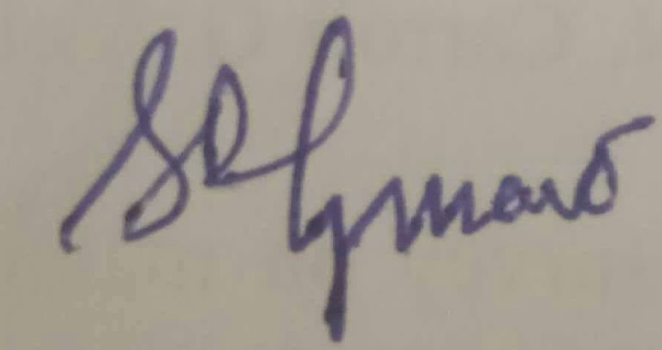

Signature
Sincerely yours
Dr. Swati Gurav..........
Corresponding author

